Pelican Park Recreational Ground  Lambwath Road  HULL. HU8 0EE  Tel: 01482-703114  Email: info@pelicanparkhull.org  Website: www.pelicanparkhull.org | 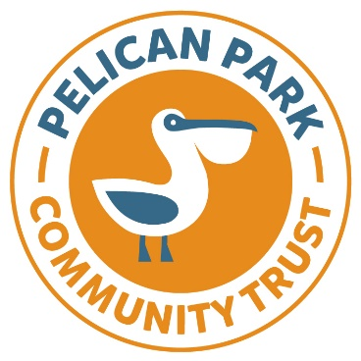
PELICAN PARK COMMUNITY TRUST
YOUTH CLUBS – LEGO 2024

Name:
Address:

Post Code:
Telephone Number:
Email:
Date of enquiry:
- Full name of child: Date of Birth:
- Full name of child: Date of Birth:
- Full name of child: Date of Birth:
School Attending:

Please note – all sessions are funded through the Lottery Community Fund
Medical Information:

Further Information:

Sessions will take place the community hall at Pelican Park. There will be a tuck shop available during the sessions selling snacks and drinks.

If you require any further information, please call the team on 01482-703114.

Once completed, please return the form to bookings@pelicanparkhull.org.uk

Thank you.

